Issue
94
For children with special needs and disabilities and their siblings
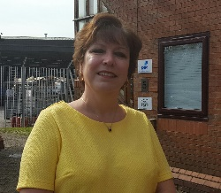
NOTES from Kim…. Once again we are just doing a short newsletter in the hope that things might change for the better. We are trying to do activities with some variety, but it’s so hard finding different things to do at the moment when you can’t hire venues. Thank you for all the tombola stuff, keep it coming. Bookings date is Monday 19th October. About 40% of the membership have not sent in their renewal and therefore will not have received this newsletter.
Covid precautions: I’m not going to rewrite our Covid policy here, however as we have finally got some official guidance about what we can and can’t do there are a couple of things I need to tell you. We are not allowed to accept children who have travelled to a session in a vehicle other than the one that belongs to their family. So no sharing lifts, no public transport, no taxi’s. It does seem harsh and I am personally not happy about it, but if complying means we can run sessions then so be it.
For children and young people who can’t attend LUP activities we do have some toys and games to send out. They are suitable for all kinds of abilities and ages please request off Claire. It might take us a day or two to get them to you.
We will be doing a Christmas appeal starting in November. We already know that some of our fundraising venues won’t be operating over the Christmas period and we are a little worried about money, especially unrestricted funding. The kind we get from our own fundraising efforts. If you can help in any way perhaps by collecting cash instead of sending Christmas cards please think of us.

Let Us Play (Wolverhampton) Registered charity number 1104506 Company LTD by Guarantee number 5042881 7 Shaw Park Business Village, Shaw Road, Wolverhampton WV10 9LE www.lupwolverhampton.org.uk 01902 546258

The parent’s only group
Our socially distanced parent support group is continuing to run. Don’t forget to tell Claire you are coming. Over the summer we did have some new members join us. The parents group is open to all adults who have paid LUP family membership and is free of charge.
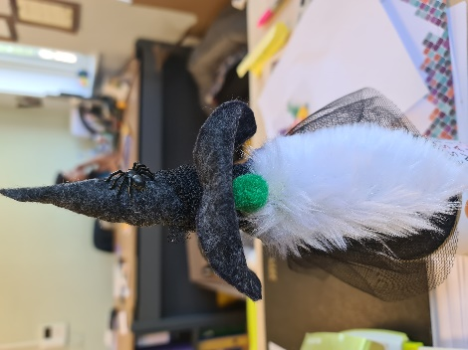
Wednesday 21st October
Halloween trolls. This is an example of one we have done in the office. I’m not sure what else to call them except they look a little like the ones you get from Scandinavia. 9:30 – 12:30. At the office 7 Shaw Park.

Wednesday 4th November.
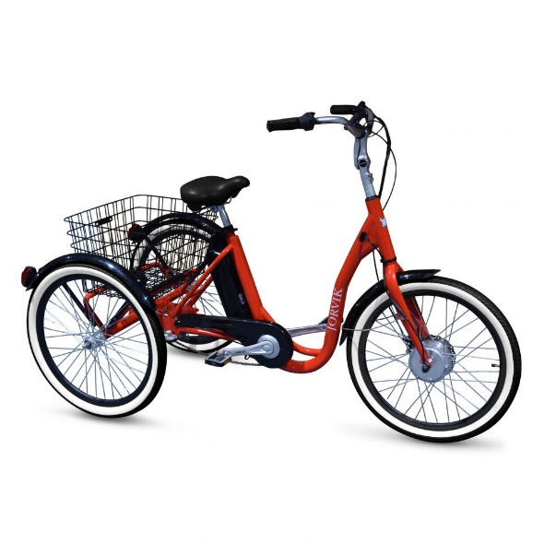
Join us at 9:30 for a hot breakfast and a bit of water colour painting. Some of our mums are going to be better at this than Kim or Claire. So you can either free paint or follow the mini lesson off Kim & Claire. Don’t worry this is quite easy and nobody will look silly.

LUP CYCLING
We have decided not to run cycling for the time being. With only 6 being allowed in the hall it’s just not justifiable to spend the money. We were hoping to restart after half term but after Christmas is looking more likely.
Track and Trace
Let Us Play is fully supportive of the track and trace system. Of course we keep registers of attendance. We also have
the QR code available in our foyer for those
who choose to use it.

There are some South Staffordshire activities on this newsletter. Priority is given to Staffordshire children where you see this symbol. However there should be some additional places for Wolverhampton families so just ask

Saturday 24th October  Dudley Zoo  Meeting at the top of the Car Park by the bench. Look out for the staff we should be obvious in our turquoise tops.  10:05 – 10:25 | 5 – 19 years  Dudley Zoo will only allow small groups to enter the admission area. This is the old entrance via the turnstiles. Our expectation (with the exception of the 1:1 places) is that we will fill a group and immediately move them into the zoo. Because of this I am asking you to arrive between 10:05 and 10:25 at the latest. If we miss our slot then I’m not sure what happens. None of the restaurants are open so packed lunch is essential. In the event of heavy rain it will be your call if you send them, but let us know. Tickets are pay in advance only. Staffordshire families are allowed to accompany.
Monday 26th October 2020.  Cinema Outing  The Elfkin Film  2 sessions  10:00am or 12:30pm  Showcase Cinema Walsall  Bentley Mill Way, Walsall WS2 0LE  (the one by Boundary Mill) | 5 – 19 years  The showing will be socially distanced so there are upper limits on the numbers we can have in the cinema. This is private hire. The film runs for 1 hour 18 mins so collection will be 11:50 am and 14:20pm. It may be possible for adults to stay depending on the numbers who request places. If you would like to accompany your own child(ren) then please be clear when you request a place. Each child is provided with a film crew pack which is simply drink sweets and popcorn. Masks needed for communal areas such as toilets. Please ensure your child has a mask.  Morning session for Staffordshire families
Tuesday 27th October  Pizza Making (and eating)  and large screen gaming session  10:30 – 2:30  Let Us Play Offices, 7 Shaw Park Business Village Shaw Road,  Wolverhampton WV10 9LE | 10 – 19 years  Make a pizza to eat for your lunch.  Large screen gaming and  free play session.  1 x 1:1 place available
Wednesday 28th October  Huggle Pets  10:00am – 12:00noon  Sensory play and animal petting and education.  Huggle Pets  Cooper Street  Wolverhampton  WV2 2JL  Mid morning break supplied.  Although only a 2 hour session we don’t expect parents to stay as space is limited in the activity space. | 5 – 19 years  This session is for those children with higher levels of need.  1: 1 places available.  There is a lovely sensory fish tank room, sensory playroom and lots of animals that just loves cuddles.  The building is quite close to Monmore Green off the Bilston Road.  They have a website if you want to check them out.
Wednesday 28th October  Biscuit Making  10:30 – 2:30  Includes Chicken Nugget lunch and crusty bread.  7 Shaw Park WV10 9LE | 5 – 19 years  Biscuit making includes a lunch.  There is one 1:1 place available.  Sorry only one session
Thursday 29th October  2 sessions  Halloween Fun Day  9:30 – 12:30 noon  Or  1:30pm – 4:30pm  Let Us Play Offices, 7 Shaw Park Business Village Shaw Road, Wolverhampton WV10 9LE | 8 – 14 years  Come dressed up if you want to. This session has a Halloween themed ‘Who Dunit’, some Halloween craft and lots of game play.
Saturday 31st October Extra Information
A socially distanced visit to Elgar the wizard who may have a small goody bag if you don’t play tricks on him. There will be BBQ food available Burgers, Sausages, cakes, drinks etc. Weather permitting we will set up the tombola.
The whole office will be decorated in a Halloween theme. We do need to do social distancing. It seems too complicated to book appointments but we are open between5:00pm and 7:30pm. If too many people arrive at one time we may ask you to wait in your car. Please tell Claire if you are coming with numbers: children and adults for catering and goody bags.
All children must be accompanied.
Please move off site when you are finished.
Please park away from the building on the other side
Of Shaw Park.

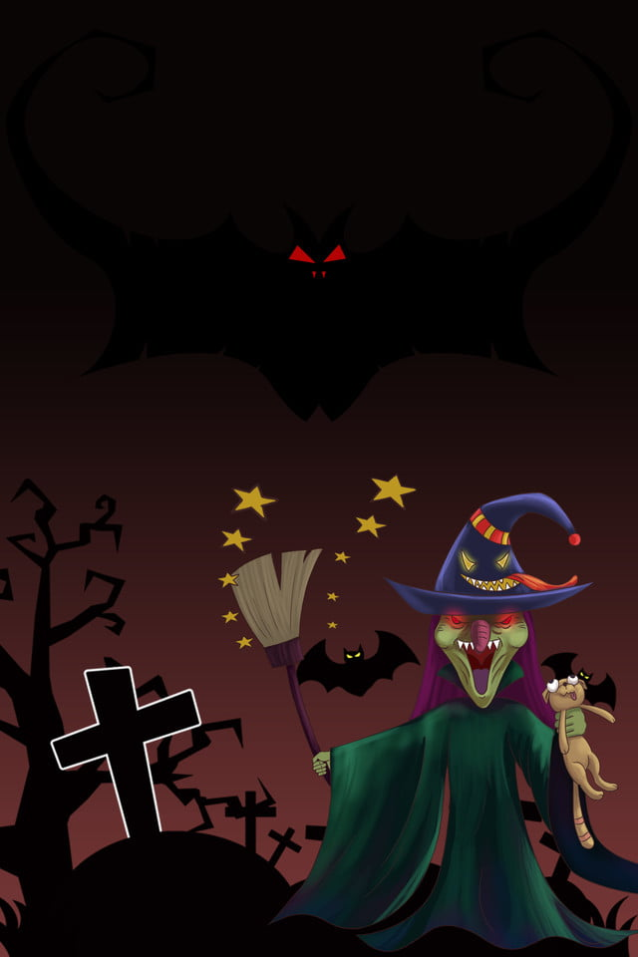
V
Dressing Up Essential
Tombola
Goody Bags
Food Available
Visit Elgar The Wizard
Saturday 31st October 2020
Between 5:00 – 7:30pm

