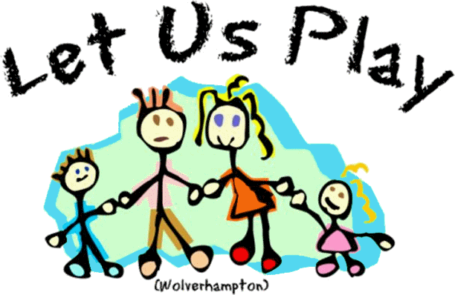
Issue
95
For children with special needs and disabilities and their siblings
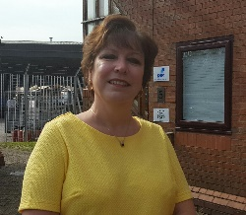
It has taken a few days after the second lockdown for the information about what we can and can’t do be published. We are allowed to do respite care, but not out of school clubs. We are allowed to run support groups in the office, but not take the group out and about. There are two Christmas activity sessions on this newsletter. It goes without saying that it is entirely up to you if you choose to send your child(ren) or not. However I would expect each child will only be allocated one session and the Christmas Grotto which will have socially distanced places for all members. It does depend a little bit on demand which is something quite hard to predict. So if you want both ask for both, but tell Claire which is your first choice. Claire will allocate on Monday 23rd November.

Just a little bit of welcome news….. Our new website is up and running. www.lupwolverhampton.org.uk. Big thank you to Stepping Stones Web Design for making it for us and teaching us how to use it. The plan is to use it much more with updates, news etc. The newsletter should be there almost a week before you receive it in the post, which is helpful for those that need to plan child care etc. Have a look we appreciate feedback.

Let Us Play (Wolverhampton) Registered charity number 1104506 Company LTD by Guarantee number 5042881 7 Shaw Park Business Village, Shaw Road, Wolverhampton WV10 9LE www.lupwolverhampton.org.uk 01902 546258
The parent’s only group
Our socially distanced parent support group has just one session. Wednesday 2nd December at 10:00am. The session is glitter houses
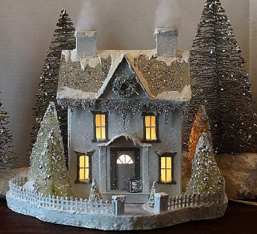
Something along these lines
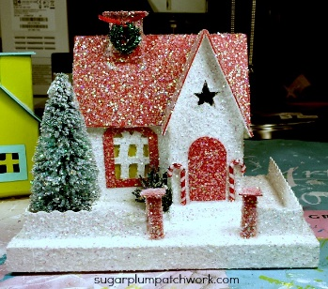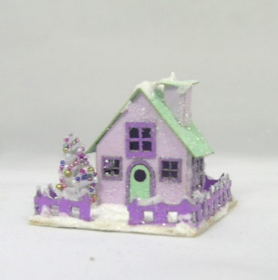
This will be quite a long session so come prepared to stay. We are going to do a Christmas themed buffet lunch (not breakfast) so we think roughly 10am to 1:00pm but stay longer if needed. The houses come flat packed, so you need an Ikea degree before you start decorating. We have some tiny outside lights but they are almost impossible to glue onto a wet house. We have quite a collection of bits and bobs perhaps have a think about what you would like to create before you come.
As ever you must book a place
The parents group will have a special meal out when restrictions are lifted.

OFFICE CLOSURE
The office will be closed the final 2 weeks of December and the first 2 weeks of January. Should you need us please ring the mobiles.
We are still collecting tombola items in the hope we can do some fundraising in the New Year. We don’t however want car boot stuff at the moment as we are short of storage.
We have been asked to share this information:
Grants for families raising disabled children available from Family Fund
The DfE has provided a further £10 million to the Family Fund which is a UK-wide charity that provides grants for essential items to families on low incomes raising disabled or seriously ill children. Families can apply for grants for a wide variety of items that they feel could help their disabled child and ease some of the everyday pressures they face. These can include kitchen appliances, computers and tablets, furniture, family breaks and day trips, sensory toys, clothing and bedding, and more. Family Fund cannot consider requests where a statutory agency has assessed a need and have a responsibility to provide the item.

Families who have previously received a grant from Family Fund before 1 April 2020 and whose circumstances have not changed can re-apply for further support. This funding is still available, and families can apply for a grant by visiting the website
https://www.familyfund.org.uk/FAQs/how-do-we-apply

Saturday 28th November  Advent Calendars  9:30 – 12:30 noon  Or  1:30pm – 4:30pm  Let Us Play Offices, 7 Shaw Park Business Village Shaw Road, Wolverhampton WV10 9LE | 5 – 19 years  If you mind which session please tell Claire. Session includes snacks and play.  All the children will get a homemade advent calendar to make and take home. We are still working on the design and contents but we are really pleased with what we have so far.  1 x 1:1place available on each session
Saturday 5th December  Christmas decorations  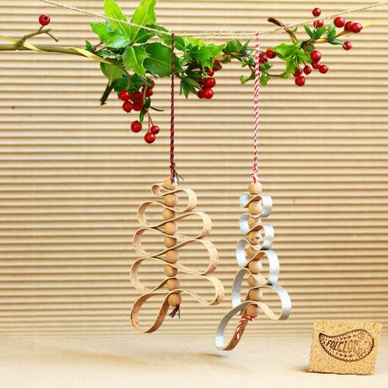  9:30 – 12:30 noon  Or  1:30pm – 4:30pm  Let Us Play Offices, 7 Shaw Park Business Village, Shaw Road, Wolverhampton WV10 9LE | 5 – 19 years  A session with 4 different decorations for you to make to take home. Includes snacks and drinks.  If you mind which session you are allocated please tell Claire.  Lots of glue and glitter.  There is a 1:1 place on each session.
Tombola
Photography
7 Shaw Park
Free café serving Christmas
themed hot and cold food

Real Reindeer
Father Christmas
Visit the LUP Grotto
Saturday 12th December
Saturday 12th December extra information
At the time of writing we have no idea which social distancing measures will be in place. However it is safe to guess that we will have to socially distance on this date. Thus no Christmas party this year. The grotto is the best idea we could come up with.
Each year we have to hold an AGM for the charity. We need to give members the chance to inspect our accounts and read a letter from our Chair. We know this is of little interest to many, but we have to do it to maintain our charitable status. The upstairs of the office will be turned into a Christmas themed café where the food is free in return for being able to write down the names attending for our AGM. If you wish accounts are available and there will be a short statement from our New Chairperson Joyce Jeavons for you to read.
We have real reindeer who you may fuss. Our Christmas tombola and of course Santa for you to visit. There is a special sleigh to sit in. In addition Haylii our very talented sessional worker will be taking photographs of the children and family groups. These will be free to all, but we are asking those that can to make a suggested £5 donation towards our unrestricted funding. Details will be sent out with the photographs on how to do that. We haven’t been able to do any of our traditional Christmas fundraising this year and we can feel the hole in our accounts.
Finally Social Distancing
No unaccompanied children
Each family group will be allocated a 30 minute time slot. If you are late then you will still be expected to depart on time. The grotto will run 12 noon until 4 o’clock. We have to be so careful that we are complying with guidelines. Tell Claire if you need a particular time slot. Happy for you to bring others in your bubble, but unless the prime minister relaxes the rules considerably by then we can’t allow you to bring friends children or those from your wider family. We ask that when you are here you socially distance from any other families present and encourage your children to do so.
YOU MUST BOOK A PLACE

