For children with special needs and disabilities and their siblings
Issue
102
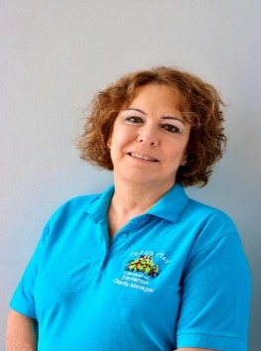
Welcome to our December issue. As ever please pay attention to
each sessions instructions. We are getting a number of families
who get mixed up and try and book onto sessions that for various reasons they are not suitable for. I am going to put compass sessions back into date order with the rest of the sessions, but background colour them blue. Compass is the ones most confusion exists around. Remember year 7 or above with a WV postcode, no siblings. Just to add to confusion Winter Funland will have places for none compass children.
This issues bookings date is Monday 7th November. Bookings close at midnight on the 6th. Can we have meal orders with bookings please. Volunteers are welcome on the Compass night out, but places must be booked asap.
We are collecting tombola prizes but we could do with them asap as most of the tombola’s are finished by the first week in December. I could also do with some volunteers on the evening of Friday 26th November for the Bilson light switch on. Not sure of times we can confirm later. Warning it can be very cold and toilets aren’t easily available.

Special shout out to Grantham Yorke Trust for funding much of the Autumn playscheme.
Let Us Play (Wolverhampton) Registered charity number 1104506 Company LTD by Guarantee number 5042881 7 Shaw Park Business Village, Shaw Road, Wolverhampton WV10 9LE www.lupwolverhampton.org.uk 01902 546258
The Parents Group
The parents group is open to one person from any family who is a member of Let Us Play. The funding for it and our ethos is very much about friendships with others who understand. You certainly don’t have to be talented to attend the craft activities, and you must never be worried about attending by yourself. It’s a big friendly bunch.
Wednesday 1st December
Xmas lunch (buffet) and Flowers
11am – 1:30pm
Office, 7 Shaw Park Business Village
Friday 17th December, Christmas Night Out, meeting at 6:45,
Elvis cabaret followed by disco
The Goodyear Pavillion Ballroom. Glitz & Sparkle required. Priority to regular attenders. One place per family, however extra places maybe available will depend on bookings and perhaps cancellations. Does not include drinks. Please note main is Turkey unless you book something else in advance.
Starter Homemade Cream of Vegetable Soup (V) Served with crusty Roll & Butter
Pavilion Melon & Prawns Sweet Honey Melon & succulent Prawns in a rich Marie Rose Sauce, on a bed of mixed leaves
Trio of Cheeses with Cranberry (V) Golden breaded Brie, Camembert & Mozzarella served on a bed of mixed leaves with a Port & Cranberry dip Main
Course Roast Norfolk Turkey Served with Pigs in Blankets & Seasoning New England
Salmon – By Pre-order Only Poached Fillet of Salmon on a bed of buttered Leeks, topped with rich Cheese Sauce Homemade Vegetable Curry & Turmeric Rice (V) (Vegan) – By Pre-order Only
All Served with Baby Roast Potatoes, Baton Carrots and Baby Sprouts
Dessert Traditional Christmas Pudding (V) Served with Brandy Sauce
White & Dark Chocolate Cheesecake (V) Chocolate Biscuit base, topped with contrasting White & Dark Chocolate Cheesecake Lemon Meringue Pie (V) Sweet Shortcrust Pastry, filled with tangy Lemon Curd finished with soft Meringue
All served with Double Cream to Finish (Coffee or Tea is included but will be available from Refreshment Stations around the room if required

Saturday 20th November  Christmas Crafting  2 sessions  9:30 – 12:30  &  1:30 – 4:30  LUP office  7 Shaw Park Business Village  WV10 9LE | 5 – 19 years  Assorted Christmas Crafting  1:1 place on each session
Wednesday 8th December  Compass Christmas Meal Out  6:30 – 8:30  The Two Greens  Old Hill, Tettenhall, Wolverhampton WV6 8QB  Please pre book your menu choice with Claire asap | Caramelised Winter Vegetable Soup (v)  Mary Prawn Cocktail†^  Oak-Smoked Chicken Liver Parfait  Mushrooms with Garlic Cream Sauce (V)  MAINS  Hand-Carved Roast Turkey  Festive Burger  Herb-Crusted Cod with Mussels†^  8oz* 30-Day-Matured Sirloin Steak (£2 supplement)  Festive Nut Roast (v)(n)  Beetroot Wellington (Ve)  PUDDINGS  Gingerbread Cheesecake (V)  Christmas Pudding (V)  Rich Chocolate & Kirsch Cherry Torte (Ve)  Choux Bun with Mixed Berries

Thursday 9th December  Grand Theatre Pantomime  Cinderella  Meet in foyer at 6:45pm please don’t be late  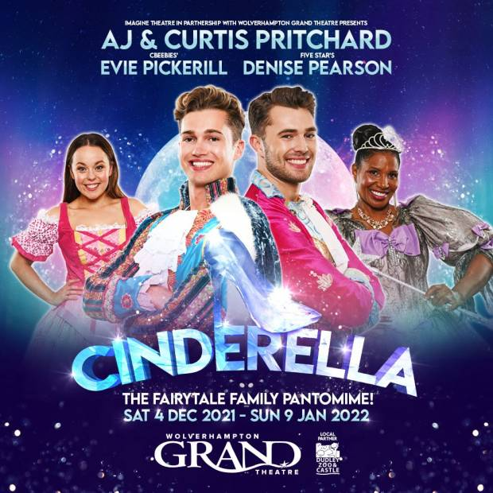 | 5 – 19 years  This is open to all ages, but we do ask that you carefully consider if this is suitable for your child. There is often strobe lighting, it can be very loud and often has bangs. Experience tells me taking the kids to the theatre is often a stressful experience.  We will provide an ice cream in the interval, but you may wish to discreetly send a drink, if you know they will need one. Please don’t send money or piles of sweets it creates arguments.  As the newsletter is going to print I don’t have a run time, so we will have to confirm this when you drop them off.  No 1:1 places

Christmas Party 11th December. Additional Information
The party is at the Coppice High School and starts at 12:00 finishing at 2:30pm. There is only one entrance gate. You need to enter via reception which is clearly marked on your right hand side. There will be a indicator showing which door you need to enter by. Parking close to the door is limited, so can we reserve this for those with mobility problems. There is a huge car park behind the building. I know some of the children will worry about a new venue, but it was impossible to get any of our regular ones. Please be very clear how many children are attending; Santa needs to know. Strictly no unaccompanied children. Buffet provided with an entertainer. It goes without saying that its noisy. Please support us by purchasing tickets for the tombola.
There is a legal requirement for us to hold a AGM each year so accounts and a letter from our chair will be available as will some of our trustees.

Entertainer
Please book places
Father Christmas
LUP AGM
Christmas Tombola
Saturday 11th December

12:00 noon
Until 2:30pm
Coppice Performing Arts
School
Ecclestone Rd, Wednesfield, Wolverhampton WV11 2QE
Christmas Party
Sunday 12th December  Winter Funland  NEC  Birmingham via coach  Coach departs LUP offices at 10:00am prompt  Return at approx 4:00pm to Shaw Park  This is a compass activity, but as we purchased enough tickets to fill a coach there should be tickets available for those that are in this years year 5 or 6 or out of area. There will be lots of walking.  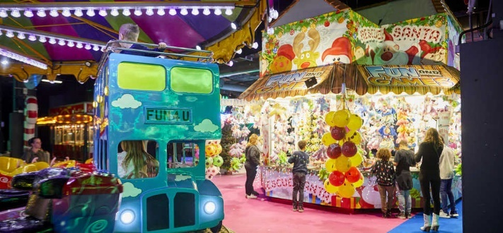 | A Compass Outing  This is a indoor fun fair with a circus show and ice rink.  There are no adrenaline rides.  So those who are brave will fine it too tame. Of course, it is noisy.  Strictly no bags, food, and big chunky coats are not necessary.  Please do not send money.  We will purchase a simple lunch.  No idea what, it will depend on queues on the day.  Please contact Claire re 1:1 places as this will depend on staffing available as it is a Sunday. It may be possible to send a carer or support your own 1;1 child.  One final word…… Phones. We would prefer that they are left at home but also understand some of them are permanently attached. Phone are bought along strictly at your own risk. There is a big danger of breakage, loss or even theft when we are in such a busy space.  It might also be helpful if you tell Claire about any aversion to spinning around or ice skating.

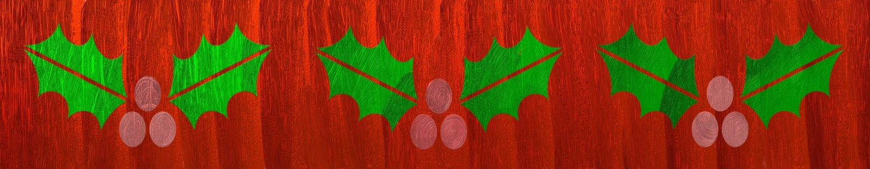

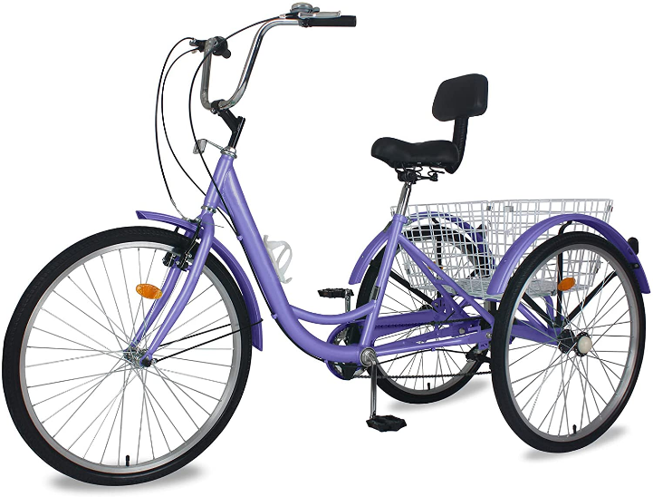
Cycling on Monday nights. The last cycling session of 2021 is on Monday 13th December. Cycling will restart on Monday 17th January 2021. If you want a place please speak to Claire. Also can our regular cyclist note that due to a big televised darts event there is unlikely to be any cycling in February. The exact dates are still to be confirmed.

___________________________________________________
I have been contacted by a local group who would like to do some volunteering for a family that could do with a day’s gardening to improve their outdoor space for their children. If you would like to discreetly tell Claire, then we can pass your details on. This group are not connected to Let Us Play, but we can vouch for their honesty and integrity. Any costs for
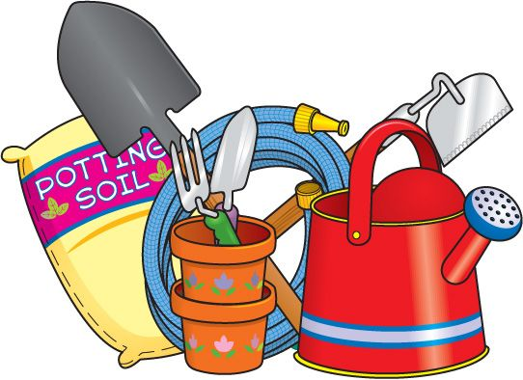
materials would have to be met by yourselves, its simply labour only.

One final note please try and remember if you have a place allocated for Arty Saturday on 13th November. There was a misprint in the last newsletter regarding the date. We are having a visit from the queen’s lieutenancy about awarding LUP a special status award. He would like to speak to parents, and we are very excited about the visit.

October half Term, Just a few pictures………………..
